APRIL NEWSLETTER
Tuesday/Thursday (2 Days)

Unit K 5825-136 Street, Surrey BC Ph:604-968-3888

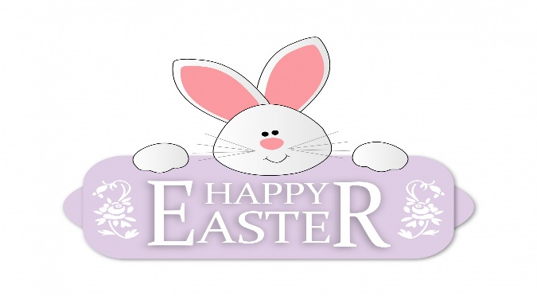
Happy April! We hope everyone had a most enjoyable and rejuvenating Spring Break. This month we will be talking about Earth Day and focusing on Reduce, Reuse, and Recycle. Registration for September 2022 is open and spaces are limited.
Themes: Easter, Earth Day, Butterflies
Letters: R, S, T Number: 8
Colors: Purple Shape: Oval

Important Dates:
Friday April 15th: Good Friday- No School
Thursday April 14th: Purple Day- Please dress your child in something purple.
Monday April 18th: Easter Monday- No School

Reminders:
- We are a NUT-Free centre. Please ensure all snacks/lunch items sent to the preschool each day do not contain nuts.
- Please send an extra set of clothes in a labelled zip-lock bag.
- Spring Weather is unpredictable, please make sure your child is prepared for all weather conditions.
- Please review COVID checklist before sending your child to preschool.

September 2022 Registration:
We are now accepting registration for September 2022.

Monthly fees:
Please submit monthly fees on the 1st day of
each month. If fees are E-transferred, please include your child’s name in the memo
ie: (Jane April fees)

